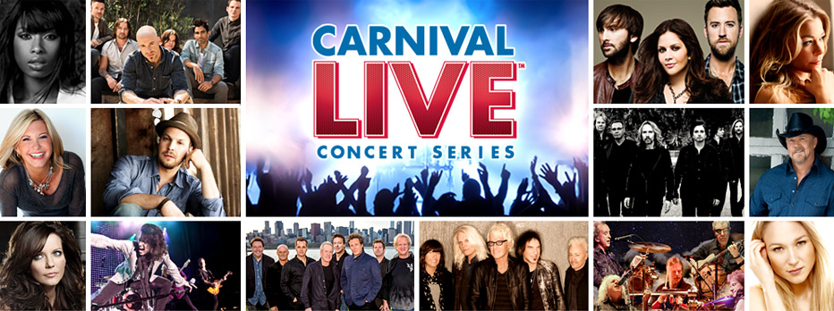
Carnival LIVE Performing Acts
This is how concerts should be done. During your cruise to The Bahamas, Cozumel or Catalina Island, California, you’ll have the unique opportunity to see a band you love rock the ship in a theater venue. Seating is limited, but there isn’t a bad seat in the house. There’s even a VIP opportunity to meet the band for a photo, plus grab a seat in one of the front rows. To get your Carnival LIVE tickets, first choose your desired sailing date and book your cruise as usual. Then, purchase your concert tickets online. Note that you must already have your cruise booked to purchase tickets. Cruising always sounds good… but it’s never sounded this good.
Carnival Live has already booked these bands across the musical spectrum:

Before the hits started flowing, Chicago had already established a reputation for
its powerful live performance. Starting in 1967, Chicago’s members exploded the conventions of
what rock music could be. Early fans like Jimi Hendrix and Janis Joplin were impressed and took
the group out on tour. Once Chicago began making records, they began setting records, with over
100 million in sales, number ones and gold singles.
Multi-platinum recording artist Daughtry has scored four No. 1 hits, garnered
four Grammy nominations, won four American Music Awards, sold over 7.5 million albums, 17
million singles worldwide and sold out concerts around the world. Daughtry’s self-titled debut
was the fastest selling rock debut in Soundscan history.
With ten multi-platinum albums and sixteen Top 30 hits, Foreigner’s musical
arsenal and exhilarating performances continue to propel sold-out tours and impressive album
sales. The band behind enduring rock anthems like “Juke Box Hero,” “Cold As Ice,” “Feels Like
The First Time,” “Urgent” and “Say You Will”.
Gavin DeGraw is a talent, who in just a few short years has become one of
today’s premier singer-songwriters. He’s done it the old-fashioned way. On the merits of his creative
abilities, perseverance and a healthy a healthy, homegrown perspective, he has established himself
as a magnetic voice in popular music.
A Grammy Award-winning recording artist, Academy Award-winning
actress and best-selling author, Jennifer Hudson is extraordinarily multi-talented. As a young singer
from humble beginnings, Hudson sang in a small Chicago church, where week after week she brought
the congregation to its feet. From there, she’s gone on to garner worldwide acclaim as an entertainer.
Jewel is an acclaimed American singer, songwriter, actress, poet, painter, philanthropist
and daughter to an Alaskan cowboy singer-songwriter. From the remote ranch of her Alaskan youth to
international stardom, the three-time Grammy nominee, whether alone or fronting a band of ace
musicians, has earned the respect of other well-known singer-songwriters, who not only invited her
to open their shows, but mentored her in the early phases of her career.

How many bands grow even more iconic with each passing year? It’s a short list, and
on it is Journey. Through all its phases and eras, twists and turns the band sees its music become more
popular as the years go on. The roadie who suggested the band name “Journey” truly had a vision.
In a career spanning five decades, Journey is blazing hotter than ever with the lineup of Neal Schon
(guitars, backing vocals), Jonathan Cain (keyboards, backing vocals), Ross Valory (bass, backing vocals),
Deen Castronovo (drums, percussion, backing vocals) and Arnel Pineda (lead vocals).
Kansas, once simply a garage band from Topeka, released their first album in 1974,
and it contained this statement: “From the beginning, we considered ourselves and our music
different and we hope we will always remain so.” In the 21st century — over 40 years later — it
certainly seems likely. Little did this now-legendary rock group realize back in the early ‘70s, what
seems “different” may just be ahead of its time.
Art is a moving target. Those who do it most successfully find shades
of emotion within themselves that change the texture of their work and how they feel about
themselves. As a result, a real artist is ever-changing. Since its 2006 inception, Lady Antebellum
had risen quickly to become country music's most influential current group.
LeAnn Rimes has sold more than 40 million albums, won two Grammy
Awards, three Academy of Country Music Awards and 12 Billboard Music Awards. Rimes is the
youngest recipient ever of a Grammy Award, and was also the first country recording artist to
win in the Best New Artist category. Rimes has placed 42 singles on the Billboard Hot Country
Songs chart, 13 of which are Top 10 hits, and has scored numerous hit singles in her career.

Critically acclaimed country group Little Big Town — consisting of members Karen Fairchild, Phillip Sweet, Kimberly Schlapman, and Jimi Westbrook — first entered the music scene more than 15 years ago with hits such as Boondocks, Bring It On Home, Good As Gone and Grammy-nominated single Little White Church. The quartet’s fifth studio album Tornado was released on September 11, 2012 and debuted at the top of the Billboard Country Chart where it stayed for five consecutive weeks. The album has been certified Platinum with sales of more than 1 million copies and features #1 hits Pontoon and Tornado.

Martina McBride is one of the most honored, admired and
awarded women in contemporary music… but is not one to rest on her laurels. Even before there
were laurels, Martina was singing country classics with father’s country band at age 7. She first
made the country charts in 1992 and has been a constant chart presence ever since. Martina’s
hits include such enduring classics like “My Baby Loves Me,” “Wild Angels,” “In My Daughter’s
Eyes,” “Safe in the Arms of Love,” and “When God-Fearin’ Women Get the Blues.”
Olivia Newton-John’s appeal seems to be timeless. Across a
career spanning more than four decades, she’s remained a creative individual and humanitarian,
adored by fans across the world. Across Olivia’s career, musical honors include four Grammy
Awards, numerous Country Music Awards, American Music Awards, and People’s Choice Awards.

If any act embodies the place to which country music has evolved in the new
century, it is Rascal Flatts. Since their inception in 1999, the trio has helped change the face of
popular music. Their trademark sound — Gary LeVox's powerfully emotive lead vocals coupled
with the soaring harmonies of Jay DeMarcus and Joe Don Rooney, set amid world-class
arrangements and production — have made the band the standard bearers for cutting-edge
country. Drawing on Nashville's best tunesmiths and their own enviable songwriting skills,
they have released, in songs like These Days, Bless The Broken Road, What Hurts The
Most and Take Me There, some of the most important and successful music to come out of
Nashville in recent years.
Formed in 1967 in Champaign, Illinois, REO Speedwagon is a band
with a never-ending desire to give their all to their fans whenever they step onstage. In their early
days, the band hopped from small gigs to even smaller gigs, hoping to get their name out. Fans
quickly realized that REO Speedwagon wasn’t just your average college party band.

Once pronounced by Bob Dylan as America’s “greatest living poet,” acclaimed singer-songwriter Smokey Robinson’s career spans over 4 decades of hits. He has received numerous awards including the Grammy Living Legend Award, NARAS Lifetime Achievement Award, Honorary Doctorate (Howard University), Kennedy Center Honors and the National Medal of Arts Award from the President of the United States. He has also been inducted into the Rock ‘n’ Roll Hall of Fame and the Songwriters’ Hall of Fame.
Born and raised in Detroit, Michigan, Robinson founded The Miracles while still in high school. The group was Berry Gordy’s first vocal group, and it was at Robinson’s suggestion that Gordy started the Motown Record dynasty. Their single of Robinson’s Shop Around became Motown’s first #1 hit on the R&B singles chart. In the years following, Robinson continued to pen hits for the group including You’ve Really Got a Hold on Me, Ooo Baby Baby, The Tracks of My Tears, Going to a Go-Go, More Love, Tears of a Clown (co-written with Stevie Wonder), and I Second That Emotion.

Spawned from a suburban Chicago basement, Styx’s soaring power ballads transformed
the arena rock landscape throughout the ‘70s and ‘80s. Today, after over a dozen studio albums,
two Super Bowl appearances, and chart-topping tours with some of the biggest names in rock…
there’s no end in sight for Tommy Shaw, James Young, Lawrence Gowan, Todd Sucherman, Ricky
Phillips and Chuck Panozzo.
After more than three decades together, 38 Special continue to bring their
signature blast of Southern Rock to over 100 cities a year. And at each and every show, thousands
find themselves amazed by the explosive power of the band’s performance. 38 Special’s many
Gold and Platinum Album awards stand in testament to the endurance of the legendary powerhouse
behind arena-rock pop smashes like “Hold On Loosely,” “Rockin’ Into the Night,” “Caught Up in
You,” “Fantasy Girl,” “Back Where You Belong,” “Chain Lightnin’” and “Second Chance
Trace Adkins is one of Country music's most accomplished entertainers.
His trademark baritone has powered countless hits to the top of the charts and turned albums
into Platinum plaques, selling over 10 million albums, cumulatively. The Grammy-nominated
member of the Grand Ole Opry is also a television personality, actor and author. He is a
spokesman for the Wounded Warrior Program, the American Red Cross and will soon complete
his eighth USO Tour.

